**Python | Pandas dataframe.aggregate()**

Python is a great language for doing data analysis, primarily because of the fantastic ecosystem of data-centric Python packages. ***Pandas***is one of those packages and makes importing and analyzing data much easier.

Dataframe.aggregate() function is used to apply some aggregation across one or more column. Aggregate using callable, string, dict, or list of string/callables. Most frequently used aggregations are:

**sum:** Return the sum of the values for the requested axis  
**min:** Return the minimum of the values for the requested axis  
**max:** Return the maximum of the values for the requested axis

***Syntax:****DataFrame.aggregate(func, axis=0, *args, **kwargs)*

***Parameters:******func :****callable, string, dictionary, or list of string/callables. Function to use for aggregating the data. If a function, must either work when passed a DataFrame or when passed to DataFrame.apply. For a DataFrame, can pass a dict, if the keys are DataFrame column names.****axis : (default 0)****{0 or ‘index’, 1 or ‘columns’} 0 or ‘index’: apply function to each column. 1 or ‘columns’: apply function to each row.*

***Returns:****Aggregated DataFrame*

For link to CSV file Used in Code, click [here](https://media.geeksforgeeks.org/wp-content/uploads/nba.csv)

**Example #1:** Aggregate ‘sum’ and ‘min’ function across all the columns in data frame.

|  |
| --- |
| # importing pandas package  **import** pandas as pd    # making data frame from csv file  df **=** pd.read_csv("nba.csv")    # printing the first 10 rows of the dataframe  df[:10] |

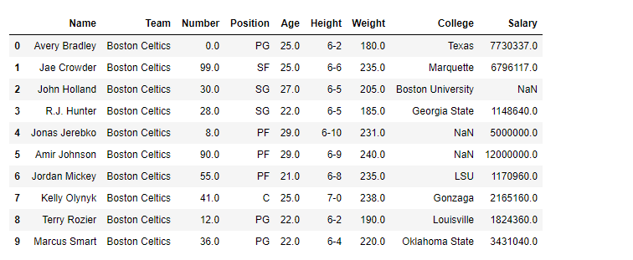

Aggregation works with only numeric type columns.

|  |
| --- |
| # Applying aggregation across all the columns  # sum and min will be found for each  # numeric type column in df dataframe    df.aggregate(['sum', 'min']) |

**Output:**  
For each column which are having numeric values, minimum and sum of all values has been found. For dataframe *df*, we have four such columns Number, Age, Weight, Salary.  
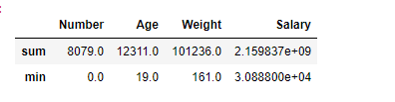

**Example #2:**

In Pandas, we can also apply different aggregation functions across different columns. For that, we need to pass a dictionary with key containing the column names and values containing the list of aggregation functions for any specific column.

|  |
| --- |
| # importing pandas package  **import** pandas as pd    # making data frame from csv file  df **=** pd.read_csv("nba.csv")    # We are going to find aggregation for these columns  df.aggregate({"Number":['sum', 'min'],                "Age":['max', 'min'],                "Weight":['min', 'sum'],                "Salary":['sum']}) |

**Output:**  
Separate aggregation has been applied to each column, if any specific aggregation is not applied on a column then it has NaN value corresponding to it.  
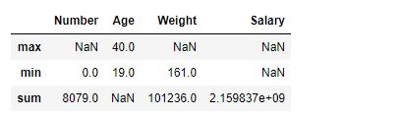

Don't miss your chance to ride the wave of the data revolution! Every industry is scaling new heights by tapping into the power of data. Sharpen your skills, become a part of the hottest trend in the 21st century.  
Dive into the future of technology - explore the [Complete Machine Learning and Data Science Program](https://www.geeksforgeeks.org/python-pandas-dataframe-aggregate/www.geeksforgeeks.org/courses/data-science-live?utm_source=geeksforgeeks&utm_medium=article_bottom_text&utm_campaign=courses) by GeeksforGeeks and stay ahead of the curve.

Last Updated : 15 Jul, 2022